**FAKE LOGO DETECTION SYSTEM**

A Project Report submitted in partial fulfillment of the degree of the

Bachelor of Technology in

**COMPUTER SCIENCE AND ENGINEERING**

By

**KANDARAPU SAISHIVANI**  **20C41A0535**

**NALIGANTI PRIMROSE 20C41A0510**

**EASTEM SAI DEERAJ 20C41A0560**

Under the Guidance of

**Mrs. N. SINDHUJA**

(Assistant Professor)



**Department of Computer Science and Engineering**

**Jayamukhi institute of technological Sciences**

**Narsampet, warangal-506 332**

**(Autonomous, Affiliated to JNTUH & Accredited by NAAC with ‘A’ Grade)**

**2024**

**Jayamukhi institute of technological Sciences**

**Narsampet, warangal – 506 332**

**(Autonomous, Affiliated to JNTUH & Accredited by NAAC with ‘A’ Grade)**

**CERTIFICATE**



This is to certify that the Project Report entitled “**FAKE LOGO DETECTION SYSTEM**” is a bonafide work of the students’ **KANDARAPU SAISHIVANI**, **NALIGANTI PRIMROSE, EASTEM SAI DEERAJ** bearing Roll No’s **20C41A0535**, **20C41A0510**, **20C41A0560** submitted in partial fulfillment of the requirements for the award of the degree of ***Bachelor of Technology*** in **CSE** during the academic year

**2023-2024.**

**Guide Head of the Department**

**Principal**

**ACKNOWLEDGEMENT**

We express our gratitude and sincere thanks to **Prof. V. JANAKI,** Principal, Jayamukhi Institute of Technological Sciences, for her constant motivation and support.

We express our gratitude and sincere thanks to **Dr. P. SRINIVAS RAO,** Head of the Department CSE, Jayamukhi Institute of Technological Sciences, for his constant motivation and support.

We are grateful to our Project Guide **Mrs.** **N. SINDHUJA,** Assistant professor, for her valuable guidance and giving us the opportunity to do our work in a better manner.

We are also thankful to our management for providing all the facilities in completing the project.

**KANDARAPU SAISHIVANI**  **20C41A0535**

**NALIGANTI PRIMROSE 20C41A0510**

**EASTEM SAI DEERAJ 20C41A0560**

# ABSTRACT

Every year, top brands lose a significant percentage of their sales to unauthorized brands which are using their same logo but in a slightly different way. Moreover such products are usually of a low quality, they also end up damaging the credibility of the brand. Many times buyers get cheated out of their earned money as they end up buying the fake products. The old system provides the way to find only the brand logo so the system is not so useful to prevent people from buying forged projects. The existing system can find only the logo but can’t find whether it’s real or fake. Since the difference is more minute people can’t identify it easily. This Logo Detection System aims to help consumers distinguish fake from the original product. Using this system, a consumer can verify whether a product real or forged. This System can also be helpful for brands struggling to fight against forged products. This system allows the users to complain the original brand about the fraudulent activities, so that the brand owners can take sufficient action to reduce the fraudulent activities and prevent the people from buying the fake products and also they can prevent themselves from damaging their credibility.

**CONTENTS**

**1. INTRODUCTION Pgno.**

1.1 Logo Detection………………………………………………………………………1-2

1.2 Scope of the Project…………………………………………………………………..3

1.3 Organization of Project Report……………………………………………………….3

1.4 Conclusion……………………………………………………………………………3

**2. LITERATURE REVIEW**

2.1 Introduction…………………………………………………………………………..4

2.2 Related Works……………………………………………………………………… 4-7

2.3 Conclusion…………………………………………………………………….……...7

**3. SYSTEM DESIGN**

3.1 Existing System………………………………………………………………………8

3.2 Proposed System……………………………………………………………………...8

3.3 System Architecture…………………………………………………………………9-10

3.4 Use-case Diagram…………………………..………………………………………..11

3.5 Conclusion……………………………………………………………………………12

**4. SYSTEM IMPLEMENTATION**

4.1 Introduction…………………………………………………………………………..13

4.2 Hardware and Software Specification………………………………………………..13

4.3 Technologies Used…………………………………………………………………14-19

**5. TESTING**

5.1 Introduction…………………………………………………………………………..20

5.2 List of Modules…………………………………………………………………… 20-28

**6. CONCLUSION**

6.1 Conclusion…………………………………………………………………………...29

6.2 Future Enhancement……………………………………………………………….…29

**7. APPENDIX**

7.1 Appendix1………………………………………………………………………….30-31

7.2 Appendix2………………………………………………………………………….32-33

7.3 Appendix3……………………………………………………………………………34

**8. BIBLIOGRAPHY**……………………………………………………………...35-36

# LIST OF FIGURES

Figure Number Figure Name PgNo.

3.3a Architecture Diagram 9

3.4a Use Case Diagram 11

4.3.3a Yolo Architecture 18

* + 1. a User Interface 22
    2. b Training Model 22
    3. c Training Graph 23

5.2.2a Detection Camera 24

5.2.3a Detecting Original Balmain Logo 25

5.2.3b Detecting Original Adidas Logo 27

5.2.3c Detecting Fake Adidas Logo 27

# LIST OF ABBREVIATIONS

YOLO - YOULOOKONLYONCE

OPENCV - OPEN SOURCE COMPUTER VISION LIBRARY SCL - SYNTHETIC CONTEXT LOGO

UML - UNIFIED MODELLING LANGUAGE

# SYSTEM AND NOTATIONS

Actor

Standard UML icon for an actor is “Stickman” icon with the name of the actor above or below the icon

Usecase

Every usecase must have a name. The usecase is shown as an ellipse containing the name of the usecase

An association between an actor and use case indicates that the actor and the usecase communicate with each other. An actor could be associated with one or several use cases

# 1. INTRODUCTION

1.1 LOGO DETECTION

Logo detecting is one of the highly challenging tasks in current computer vision. Logo detection in the unclear and unconstrained images is very crucial for type of the real world vision applications. The challenging task in detection is due to the different sizes of the logos present. The existing Logo detection systems traditionally need a small logo class with large size data with bounding boxes using the real time object detection. In this System the logo is detected using the You Look Only Once (YOLO) algorithm.

In this work the logo is identified and it is displayed in a grid using the real time detection systems. If the logo is original the user can move further and buy the product. When the logo is fake the user can report it to the original brands through this system. The main motto of this idea is to restrain people from buying the fake products and help the brands to maintain their credibility.

With the increase in digital marketing and e-commerce, logos have become an essential aspect of a brand's identity. Logos are used to establish brand recognition and build consumer trust. However, the proliferation of counterfeit products has made it increasingly difficult to distinguish between genuine and fake logos. This has led to the need for effective fake logo detection systems. Fake logo detection involves identifying and distinguishing between genuine and fake logos. It is a challenging task due to the high degree of similarity between genuine and fake logos. Therefore, several techniques have been developed to detect fake logos, including image analysis, machine learning, and deep learning.

Python is a popular programming language for developing machine learning and deep learning models. It offers several libraries and frameworks that simplify the process of developing and implementing these models. This has led to the development of several fake logo detection systems using Python.

In this review, we provide a comprehensive overview of the different techniques that have been used for detecting fake logos using Python. We discuss the strengths and weaknesses of each technique and highlight the challenges that still need to be addressed in this field. This review will serve as a useful resource for researchers and practitioners who are interested in developing and implementing fake logo detection systems.

# 

# Fake logo detection is a challenging problem that has received significant attention in recent years. With the rise of e- commerce and digital marketing, logos have become an important aspect of branding and consumer trust. However, the proliferation of counterfeit products has made it increasingly difficult to distinguish between genuine and fake logos, leading to the need for effective fake logo detection systems.

# Previous research on fake logo detection has focused on different techniques, including image analysis, machine learning, and deep learning. These techniques have been used to develop various approaches for detecting fake logos, such as texture analysis, feature extraction, and classification.

# Python has become a popular programming language for developing machine learning and deep learning models due to its simplicity, flexibility, and extensive libraries and frameworks. Several Python libraries and frameworks, such as OpenCV, TensorFlow, and PyTorch, have been used for developing fake logo detection systems.

# Different datasets have been used for training and testing fake logo detection systems, such as the Logos in the Wild dataset and the Fake Logos dataset. These datasets contain a large number of images of logos and are used to train and test the accuracy of the detection systems.

# Fake logo detection has several applications, including e- commerce, anti-counterfeiting, and brand protection. Effective fake logo detection systems can help prevent the sale of counterfeit products and protect the reputation of brands.

# In this review, we aim to provide a comprehensive overview of the different techniques that have been used for detecting fake logos using Python. We will review the strengths and weaknesses of each technique, describe the different datasets used for training and testing, and highlight the challenges that need to be addressed in this field.

# 1.2 SCOPE OF THE PROJECT

To help the people by making them buy only the original products and also help the brands to maintain their standard. To help the brands to know where the fake products are being sold and help to find them out and take sufficient action on that case. Finally it helps every people to buy quality and original products rather than the fake one.

# 1.3 ORGANIZATION OF THE PROJECT REPORT

The report begins by examining the problem space. It investigates current and upcoming studies on the subject. It starts with Logo detection and recognition and then moves on to dataset construction. The study then details the constraints imposed by these arrangements and how the proposed system will address them. It takes you on a tour of the System's architecture and functionality. Finally, it considers the suggested system's scope, prospective applications, and conclusion.

# 1.4 CONCLUSION

In order help the people to buy the quality products we use this System. As logos are the common

mode of identification of the original product, it is very important to find the originality of the logo

of the product while purchasing. In these ways this system will help the brand owners and the

customers.

# 2. LITERATURE REVIEW

# 2.1 INTRODUCTION

A literature review is a body of text that aims to review the critical points of current knowledge on and/or methodological approaches to a particular topic. It is a secondary source and discusses published information in a particular subject area and sometimes information in a particular subject area within a certain time period. Its ultimate goal is to bring the reader up to date with current literature on a topic and forms the basis for another goal, such as future research that may be needed in the area and precedes a research proposal and maybe just a simple summary of sources.

# 

# 2.2 RELATED WORKS

Deep Learning Logo Detection with Data Expansion by Synthesizing Context

AUTHOR: Hang Su, Xiatian Zhu ,Shaogang Gong

YEAR: 2017

METHODOLOGIES USED: YOLO

DESCRIPTION:

Logo detection in unconstrained image is challenging, particularly when only very sparse labelled training images are accessible due to high labelling costs. Synthetic Context Logo (SCL) training is the method to increase model robustness against unknown background clutters, resulting in superior logo detection performance.

Automatic Logo Detection and Extraction using Singular Value Decomposition

AUTHOR: Umesh D. Dixit and M. S. Shirdhonkar

YEAR: 2016

METHODOLOGIES USED: Singular Value Decomposition

DESCRIPTION:

Automatic logo detection and extraction from document image implementation with the use of

Mathematical tool Singular Value Decomposition (SVD). The method proposed is tested publicly

available realistic document image database Tobacco-800. We also compared the results of

proposed method with current method. Average logo detection rate is achieved with proposed

method.

Detecting TV logos from Web-Scale Videos

AUTHOR: Qiting Ye, Zhao Luo, Xiabing Xiao, Shiming Ge

YEAR: 2017

METHODOLOGIES USED: Deep Learning, Convolutional neural Networks

DESCRIPTION**:**

### The key frame module first extracts several frames with the shot segment detection. In this manner, the data can be drastically reduced. Then, the spatial verification module takes the logo as the input and identifies them as real logos or not by performing the classification task within a ResNet network. Finally, the temporal verification module further identifies the detection results by checking the temporal consistency of logo locations.

Deep Learning for Logo Recognition

AUTHOR: Hang Su, Xiatian Zhu, Shaogang Gong

YEAR: 2017

METHODOLOGIES USED: Deep Learning

### DESCRIPTION:

Our recognition pipeline is composed of a logo region proposal followed by CNN specifically trained for logo classification and identification, even if they are not right localized. Experiments are carried out on the FlickrLogos-32 dataset classes, and we evaluate the effect of the recognition performance of synthetic versus real data augmentation, and image pre-processing. Experimental result confirms the feasibility of proposed method.

The Halal Logo Classification by Using NVIDIA DIGITS

AUTHOR: Hendrick, Chih-Min, Wan, Aripriharta, Ciou-Guo, Jhe, Ping-Cheng, TsuGwo-Jia, Jong

YEAR: 2019

METHODOLOGIES USED: Deep Learning, Caffe, Halal Logo, GoogleLeNet

### DESCRIPTION:

The Halal logo is not the same for every country. In both Halal logo Indonesia and Taiwan are different. In this research, the deep learning methodology has been applied to classify the halal logo. The classification of logo is based on the caffe framework with GoogleLeNet architecture. As the datasets, the halal logo and soft drink logo has been created. This purpose of the study is to produce a deep learning pre-trained model of the halal logo.

Signature and Logo Detection using Deep CNN for Document Image Retrieval.

AUTHOR: Nabin Sharma, Ranju Mandal, Rabi Sharma, UmapadaPal and Michael Blumenstein

YEAR: 2019

METHODOLOGIES USED: R-CNN; Deep Learning; Document retrieval; Signature detection

### DESCRIPTION:

### A large intra-category variance among signature and logo samples possess challenge to traditional hand-crafted feature extraction-based approaches. Hence, the potential of deep learning-based an object detectors namely, Faster R-CNN and YOLO v2 were examined for automatic detection of signatures and logos from scanned administrative document. Four different network models namely ZF, V GG16, V GGM and YOLO v2.

Sport Teams Logo Detection Based On Deep Local Features

AUTHOR: Andrey Kuznetsov, Andrey Savchenko

YEAR: 2019

METHODOLOGIES USED: logo detection, sport logo, NHL dataset, local descriptors, SIFT, SURF, ORB, BRISK, FREAK, AKAZE, DELF

DESCRIPTION:

Logo detection in an unconstrained environment is a experimental tasks. The problem lies in the small size of logo that are detected and different representation of logos. we propose an approach based on local descriptor calculation (SIFT, SURF, ORB, BRISK, FREAK, AKAZE) and provide the results of conducted experiments. Second, we approach based on deep local features (DELF), which are pre-trained on Google Landmarks dataset, and compare them with classic local features.

Unconstrained Logo Dataset with Evaluation by Deep learning Methods

AUTHOR: Nhat-DuyNguyen, ThuaNguyen, TienDo, ThanhDucNgo and Duy-Dinh Le1

YEAR: 2019

METHODOLOGIES USED: logo detection, sport logo, NHL dataset, local descriptors, SIFT, SURF, ORB, BRISK, FREAK, AKAZE, and DELF

DESCRIPTION:

Detecting the appearance of logo in image is applied to many applications, such as brand recognition for marketing analysis and intellectual property rights protection we provide an evaluation of the state of the art model based on Deep learning including YOLO, Faster RCNN, Mask RCNN, RetinaNet in order to illustrate how well these models overcome unconstrained condition. Comparative evaluations demonstrate the best performance on U15-Logos.

Clothing Brand Prediction via Logo Recognition

AUTHOR: Kuan-HsienLiu1, FeiWang2, Tsung-JungLiu2

YEAR: 2020

METHODOLOGIES USED: YOLOV3

DESCRIPTION**:**

Several dense blocks are designed to improve prediction accuracy based on clothing brand logo. We construct a new clothing dataset with brand and logo information to facilitate this task. In the experiment, we show our method can achieve better performance than some state-of-the-art methods.

Detecting Motion Blurred Vehicle Logo in IoV Using Filter-DeblurGAN and VL-YOLO

AUTHOR : Linghua Zhou, Weidong Min, Member, IEEE, Deyu Lin, Member,IEEE, Qing Han, Ruikang Liu

YEAR : 2020

METHODOLOGIES USED: Filter-DeblurGAN and VL-YOLO

DESCRIPTION**:**

A new approach is proposed to detect vehicle logo under motion blur with the combination of Filter-DeblurGAN and Vehicle Logo-YOLO. Filter-DeblurGAN possesses a judgment mechanism, which can determine whether the image need to be deblurred based on the degree of blur in every image. It can also deblur images with random resolution. Filter-DeblurGAN solves the defect that DeblurGAN lacks the judgment mechanism and is too hard resolution.

# 2.3 CONCLUSION

This chapter presented the advantages and limitations of different logo detection applications. This helps in developing and identifying the ideal techniques that can be used to develop an efficient application with high accuracy and minimal limitations. There has been much research and discussion conducted on logo detection applications.

**3. SYSTEM DESIGN**

3.1 EXISTING SYSTEM

The existing system provides the way to find only the brand logo so the system is not so useful to prevent people from buying forged projects. The existing system can find only the logo but can’t find whether its real or fake. Since the differences are more minute people can’t identify it easily**.** In The Existing system just the logo name is displayed with the grid like structure around the logo and not much thing to find the fake one. The old systems that didn’t use the Yolo very much struggled to find the logo in the real time environment. Since the old systems scanning speed is less and it doesn’t have the ability to find the small logo images.

3.2 PROPOSED SYSTEM

The proposed fake Logo Detection System aims to help consumers distinguish fake from the original product. Using this system, a consumer can verify whether a product real or forged. This System can also be helpful for brands struggling to fight against forged products. This system allows the users to complain the original brand about the fraudulent activities, so that the brand owners can take sufficient action to reduce the fraudulent activities and prevent the people from buying the fake products and also they can prevent themselves from damaging their credibility.

# 3.3 SYSTEM ARCHITECTURE

Overall system architecture for the proposed system is shown in Figure

3.3a as below.

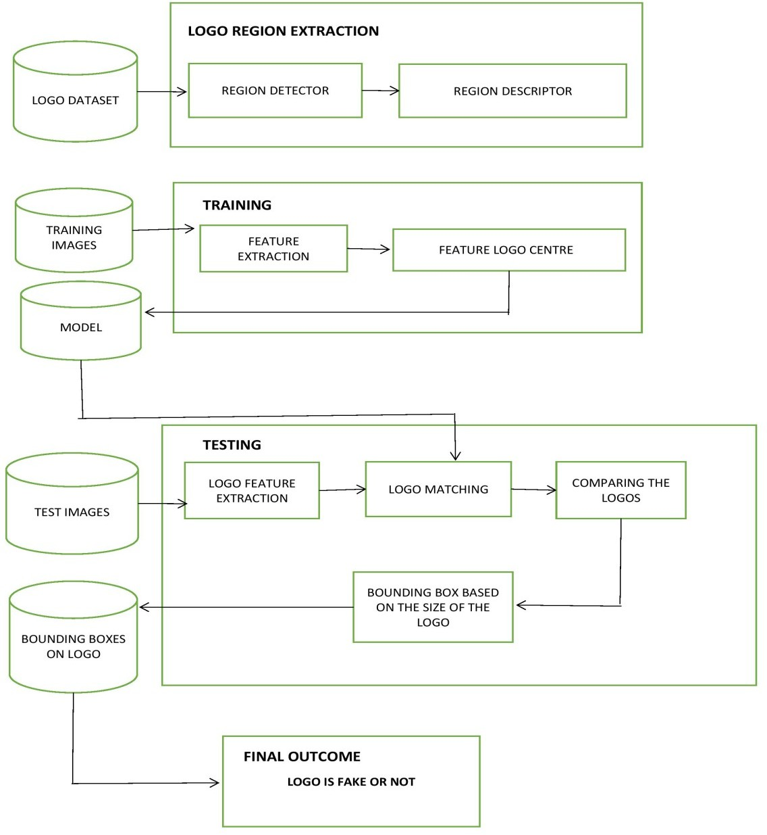

**Fig 3.3a Architecture Diagram**

The software system design, program methodologies, and system approaches employed in the creation of programming are described in this work. Accepting the data and commands, executing different commands and getting the required output. In this system the input is the logo of the product detected in real time and the output is whether the logo is fake or real. The system first compares the input with the trained dataset from the admin side. For comparing the images in the dataset the Tensorflow module is used which is one of the main model of the deep learning library .For real time input OpenCv is used. OpenCv is the python library helps to access the camera. For the real time detection and analyzing the originality of logo the Yolo algorithm is been used.

# 3.4 USECASE DIAGRAM

The use case for the proposed system. System modeling has been done through a use case that represents a user's interaction with the system that shows the relationship between the user and the different use cases in which the user is involved.

The overall system architecture for the proposed system is shown in Figure

3.4a as below

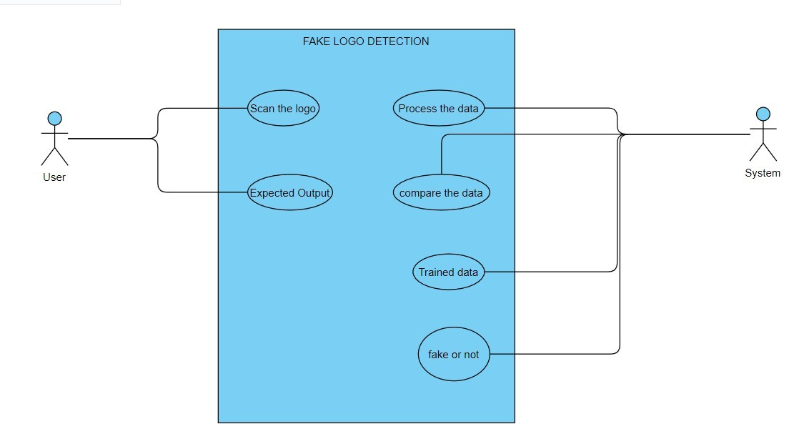

**Fig 3.4a Use Case Diagram**

# 3.5 CONCLUSION

In this chapter, the system is divided into various modules for better understanding and the working of several aspects of the application. Also, the UML diagrams are drawn up for the proposed system to highlight the interactions between the modules and to analyze the efficiency of their capabilities. As a result, the proposed Augmented Reality app is secure and can streamline effective and efficient work for the Customers.

# 4. SYSTEM IMPLEMENTATION

# 4.1 INTRODUCTION

For the implementation of the proposed system, the Python has been chosen for several reasons. First, it provides all the necessary tools to create interactive environments in a relatively simple way. Second, it has a complete and well documented. And finally, it can run on different platforms such as PCs, consoles, mobile devices or web.

# 

# 4.2 HARDWARE AND SOFTWARE SPECIFICATIONS

## 

## 4.2.1 HARDWARE REQUIREMENTS

Processor: Intel i5/i7/i9 (8thGenorabove)

Download speed of 10 Mbps or greater

RAM: 8 GB (or above)

Hard disk: 20GB (or above)

## 

## 4.2.2 SOFTWARE TOOLS REQUIRED

Python 3.7 or above

Tensor flow OpenCV

# 4.3 TECHNOLOGIES USED

# 4.3.1 OPENCV

OpenCV is the open-source library for the computer vision, machine learning, and image processing and now it plays a major role in real-time operation which is very important in today’s systems. By using it, one can process images and videos to identify objects, logos, faces, or even handwriting of a human. When it integrated with various libraries, such as NumPy, python is capable of processing the OpenCV array structure for analysis. To identify image pattern and its various features we use vector space and perform mathematical operations on these features. When OpenCV was designed the main focus was real-time applications for computational efficiency.

## 4.3.1.1 OpenCV Functionality

1.Image/video I/O, processing, display

2.Object/feature detection

3.Geometry-based monocular or stereo computer vision

4.Computational photography

5.Machine learning& clustering

6.CUD Acceleration

## 4.3.1.2 Applications of OpenCV

1. Face recognition

2. Automated inspection and surveillance

3. Number of people count (foot traffic in a mall, etc)

4. Vehicle counting on highways along with their speeds

5. Interactive art installations

6. Anamoly (defect) detection in the manufacturing process (the odd defective products)

7. Street view image stitching

8. Video/image search and retrieval

9. Robot and driver-less car navigation and control

10. Object recognition

11. Medical image analysis

12. Movies–3D structure from motion

13. TV Channels advertisement recognition

# 4.3.2 TENSORFLOW

Tensorflow is an open-source library for numerical computation and large-scale machine learning that ease Google Brain TensorFlow, the process of acquiring data, training models, serving predictions and refining future results. TensorFlow is at present the most popular software library. There are several real-world applications of deep learning that makes TensorFlow popular. Being an Open-Source library for deep learning and machine learning, TensorFlow finds a role to play in text-based applications, image recognition, voice search and many more. Deep Face, Facebook’s image recognition system, uses TensorFlow for image recognition. It is used by Apple’s Siri for voice recognition. Every Google app that you use has made good use of TensorFlow to make your experience better. The TensorFlow Object Detection API is an open-source framework built on top of TensorFlow that makes it easy to construct, train and deploy object detection models.

There are already pre-trained models in their framework which are referred to as Model Zoo.

It includes a collection of pre-trained models trained on various datasets such as the

* COCO (Common Objects in Context) dataset
* The KITTI dataset
* The Open Images Dataset.

As you may see below there are various models available what is different in these models. These various models have different architecture and thus provide different accuracies but there is at rade-off between speed of execution and the accuracy in placing bounding boxes. Tensorflow bundles together Machine Learning and Deep Learning models and algorithms. It uses Python as a convenient front-end and runs it efficiently in optimized C++. TensorFlow is at present the most popular software library. There are several real-world applications of deep learning that makes TensorFlow popular. Being an Open-Source library for deep learning and machine learning, TensorFlow finds a role to play in text-based applications, image recognition, voice search and many more. DeepFace application Facebook’s image recognition system, uses TensorFlow for image recognition. It is used by Apple’s Siri for voice recognition. Every Google app that you use has made good use of TensorFlow to make your experience better.

4.3.3 YOLO

The YOLO framework (You Only Look Once) on the other hand, deals with object detection in a different way. It takes the entire image in a single instance and predicts the bounding box coordinates and class probabilities for these boxes. The biggest advantage of using YOLO is its superb speed; it’s incredibly fast and can process 45 frames per second. YOLO also understands generalized object representation.

This is one of the best algorithms for object detection and has shown a comparatively similar performance to the R-CNN algorithms. Compared to the approach taken by object detection algorithms before YOLO, which repurpose classifiers to perform detection, YOLO proposes the use of an end-to-end neural network that makes predictions of bounding boxes and class probabilities all at once. Following a fundamentally different approach to object detection, YOLO achieves state-of-the-art results beating other real-time object detection algorithms by a large margin. In addition to increased accuracy in predictions and a better Intersection over Union in bounding boxes (compared to real-time object detectors), YOLO has the inherent advantage of speed. While algorithms like Faster RCNN work by detecting possible regions of interest using the Region Proposal Network and then perform recognition on those regions separately, YOLO performs all of its predictions with the help of a single fully connected layer. Methods that use Region Proposal Networks thus end up performing multiple iterations for the same image, while YOLO gets away with a single iteration. The YOLO algorithm works by dividing the image into N grids, each having an equal dimensional region of SxS. Each of these N grids is responsible for the detection.

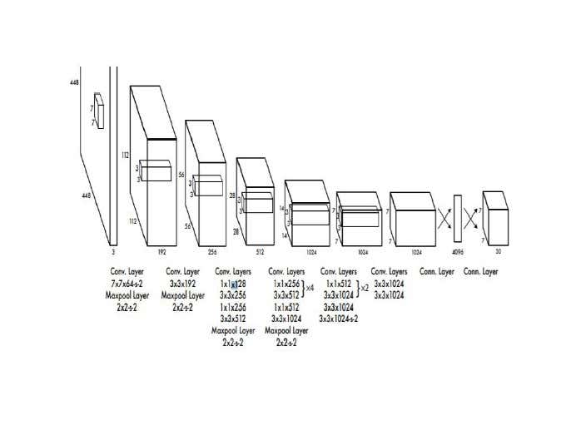

**Fig 4.3.3a YOLO Architecture**

# SAMPLE LOGO DATASETS NAME:

# Samsung

# Pepsi

# Lays

# Mars

# Oreo

# Heinz

# Marvel

# PlayStation

# Chevrolet

# Burger King

# Hp

# Fila

# Microsoft

# Chrome

# NASA

# Reebok

# Oral b

# Cowbell

# Peak milk

# Twitter

# Google

# Adidas

# Android

# Nutella

# Puma

# Pringles

# Sprite

# Tesla

# Netflix

# Zara

# 5. TESTING

# 5.1 INTRODUCTION

# Testing is performed to identify errors. It is an integral part of the entire development and maintenance process. The goal of the testing during this phase is to verify that the specification has been accurately and completely incorporated into the design, as well as to ensure the correctness of the design itself. For example, the design must not have any logic faults the design is detected before coding commences, otherwise, the cost of fixing the faults will be considerably higher as reflected. Detection of design faults can be achieved by means of inspection as well as a walkthrough.

# 5.2 LISTOFMODULES

# 5.2.1 TRAININGMODULE:

# One of the best ways to improve deep learning performance is to improve the data. Custom Dataset created with the help of sample images which then augmented using data augmentation techniques to add more data to the dataset. In the proposed system the logo dataset consists of two classes Positives and Negatives.

The positive dataset consists of the whole set of images of the original brands. Only original brands logos are present in the positives. There are multiple images being collected for each and every brand for the sake of getting the accurate results. The intensities of images taken are gray scale and normal rgb colored images.

The Negative dataset consists of the whole set of images of the original brands. Only Fake brand logos are present in the Negatives .There are multiple images being collected for each and every brand for the sake of getting the accurate results. The intensities of images taken are grayscale and normal rgb colored images.

The data training can be carried out on the various training techniques and the training time .the epoch time and the way of grouping the batches is very much important while training the dataset.

An epoch is a term indicates the number of passes of the entire training dataset the machine learning algorithm has completed. The data can be grouped into multiple batches like 8, 16, 32, 64 etc. The no of batches is very much related to the epoch time. If the number of batches are high the data training will be fast and it consumes less epoch time. These were the processes that happen while training the dataset.

DATASET COLLECTION:

Gather a diverse dataset containing images of both genuine and fake logos. This dataset should cover a wide range of logo variations, lighting conditions, backgrounds, and potential sources of forgery.

DATA PREPROCESSING:

Perform preprocessing steps on the collected dataset to enhance the quality and consistency of the images. This may include resizing the images, normalizing pixel values, and removing noise or artifacts.

FEATURE EXTRACTION:

Extract relevant features from the logo images that can differentiate between genuine and fake logos. Commonly used features include texture, shape, color

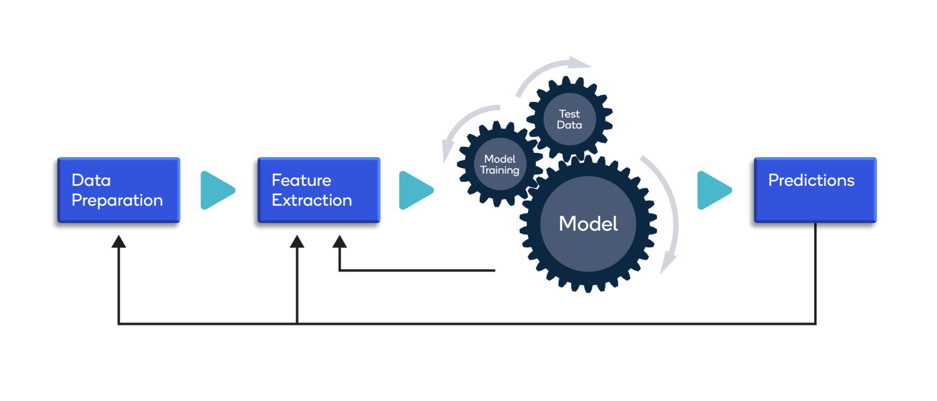

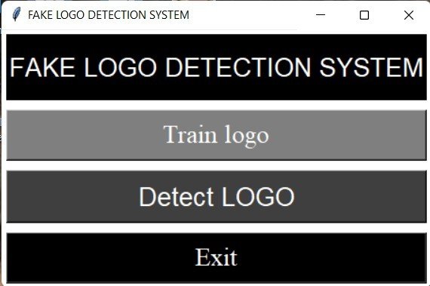

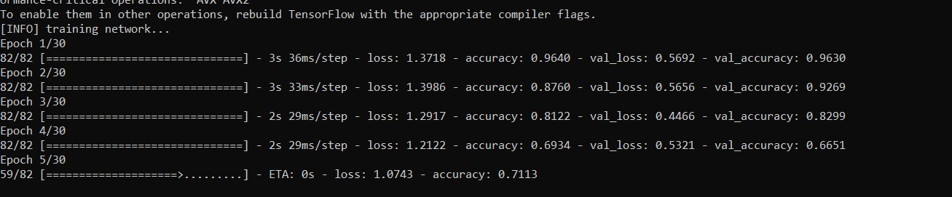 **Fig 5.2.1a User Interface**

**Fig5.2.1b Training Model**

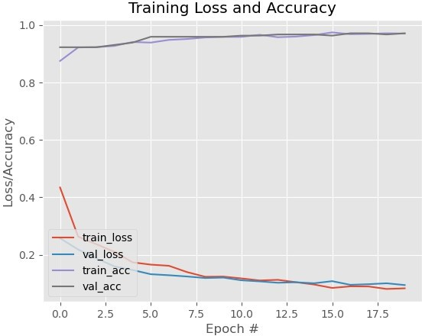

**Fig 5.2.1c Training Graph**

## 5.2.2 THE DETECTION MODULE

After the completion of the training module the detection takes place. In this module the main aim is to detect the region of the logo. Once the training is completed the model file is generated which is primarily used to compare the logo detected in real-time with the logo in the dataset. The primary component required for the detection is the camera .when the camera is turned on the logo is shown in front of the camera and it starts detecting it and it analyze the results about the logo. These were the processes that take place in the detection module of the fake logo identification system.

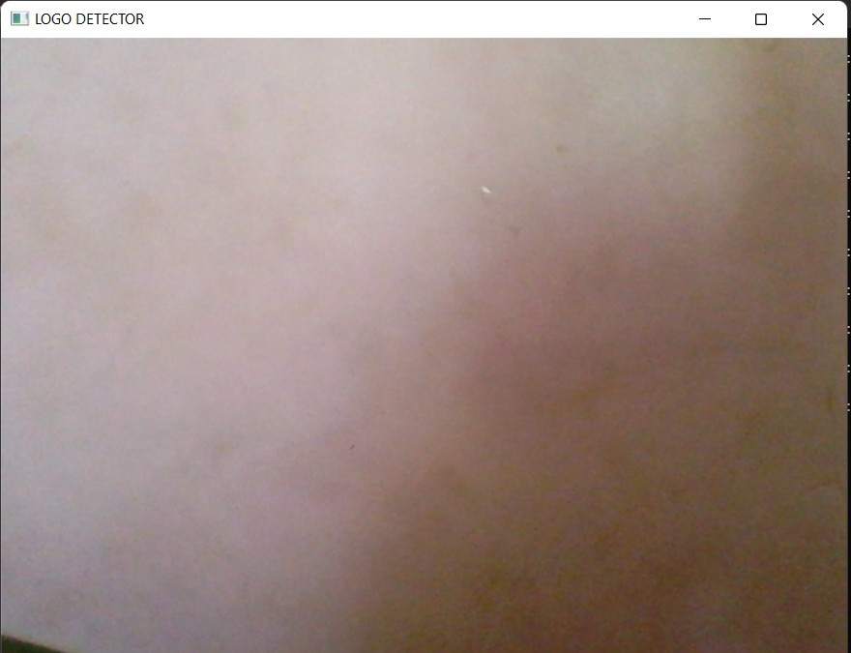

**Fig 5.2.2a Detection Camera**

### 5.2.3 THE OUTPUT MODULE

### This is the final phase in which the output is shown to the user after analyzing all the factors. The output is shown in a bounding box labeled as “Original Brand logo” And “Fake Brand Logo”. So in this phase the output user got will be useful for him to buy the original product and prevent themselves from buying it. The system differentiates the original and fake ones by comparing with the elements in the dataset.

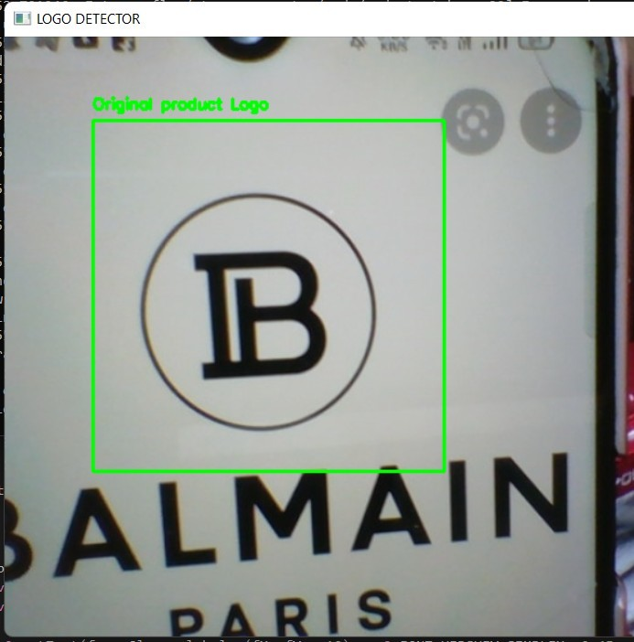

**Fig 5.2.3a Detecting Original Balmain Logo**

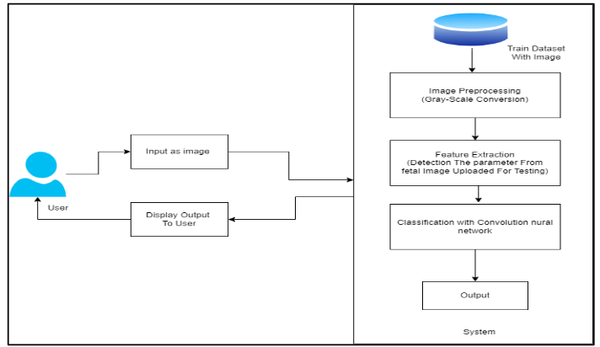

SYSTEM ARCHITECTURE

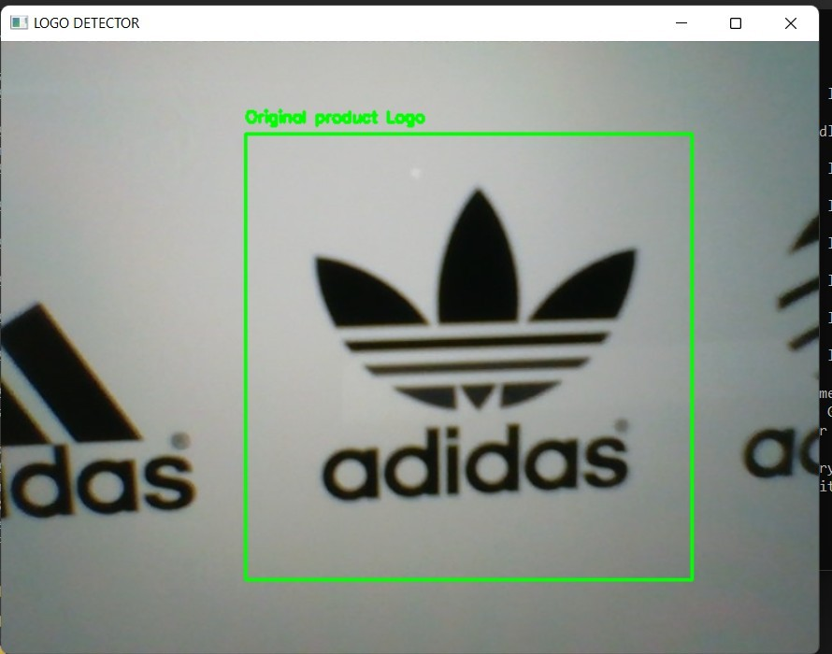

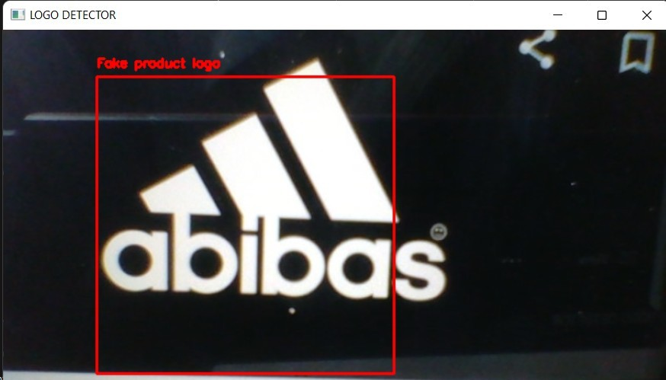 **Fig5.2.3b Detecting Original Adidas Logo**

**Fig 5.2.3c Detecting Fake Adidas Logo**

* User
* Upload Image

The user can click and upload images in .jpg or .png format of the logo they want to detect.

* Logo Detection

Once the logo is uploaded, the system will analyze the image based on parameters such as dimensions, color, text, etc.

After examining these parameters, the system generates a score of less than 90% means that the logo is fake.

**6. CONCLUSION**

### 6.1 CONCLUSION

As Logos are the common mode of identification of the original product, it is very important to find the originality of the logo of the product while purchasing. But road maintenance is a very critical task and includes numerous manpower. In This Project work we presented a new “Fake Logo Detection System” Which is definitely the need of an hour for the people and the brand owners. This System provides its own way to find the logo and display in a labeled structure using the yolo algorithm that is used in many real time detection systems. Yolo Algorithm makes the system more efficient than the other existing system. Finally, this System Creates great impact on the market due to its importance to the users and the product owners.

### 6.1 FUTURE ENHANCEMENTS

The proposed fake Logo Detection System aims to help consumers distinguish fake from the original product. Using this system, a consumer can verify whether a product real or forged. This System can also be helpful for brands struggling to fight against forged products. In future it can be developed in a way users can complain the original brand about the fraudulent activities, so that the brand owners can take sufficient action to reduce the fraudulent activities and prevent the people from buying the fake products and also they can prevent themselves from damaging their credibility.

# 7. APPENDIX

# 7.1 APPENDIX 1

fromsklearn.preprocessing import LabelEncoder from sklearn.model_selection import train_test_split from sklearn.metrics import classification_report fromkeras.preprocessing.imageimportimg_to_array from keras.utils import np_utils

fromlenet.nn.convimportLeNet from imutils import paths

importimutils

importmatplotlib.pyplotasplt import numpy as np

importargparse import cv2 import os

ap = argparse.ArgumentParser() ap.add_argument('-d','--dataset',required=True,

help='path to the input dataset of Logos') ap.add_argument('-m','--model',required=True,

help='pathtooutputmodel') args = vars(ap.parse_args()) data = []

labels=[]

forimagePathinsorted(list(paths.list_images(args['dataset']))): image = cv2.imread(imagePath)

image=cv2.cvtColor(image,cv2.COLOR_BGR2GRAY) image = imutils.resize(image, width=28)

#28 x 28 x 1 image = img_to_array(image)

data.append(image)

label=imagePath.split(os.path.sep)[-3]

label='OriginalProductLogo'iflabel=='positives'else'FakeProductLogo' labels.append(label)

data=np.array(data,dtype='float')/255.0 labels = np.array(labels)

le=LabelEncoder().fit(labels)

labels=np_utils.to_categorical(le.transform(labels),2) classTotals = labels.sum(axis=0)

classWeight=dict()

for i in range(0, len(classTotals)):

classWeight[i]=classTotals.max()/classTotals[i]

(train,test,train,test)=train_test_split(data,labels,test_size=0.20,stratify=labels, random_state=42)

print('[INFO]compilingmodel...')

model = LeNet.build(width=28, height=28, depth=1, classes=2) model.compile(loss=['binary_crossentropy'],optimizer='adam',metrics=['accuracy'])

print('[INFO] training network...')

H=model.fit(trainX,trainY,validation_data=(testX,testY),class_weight=classWeight, batch_size=64, epochs=30, verbose=1)

print('[INFO]evaluatingnetwork...')

predictions = model.predict(testX, batch_size=64) print(classification_report(testY.argmax(axis=1),predictions.argmax(axis=1),

target_names=le.classes_))

print('[INFO]serializingnetwork') model.save(args['model'])

plt.style.use('ggplot') plt.figure()

plt.plot(np.arange(0, 30), H.history['loss'], label='train_loss') plt.plot(np.arange(0, 30), H.history['val_loss'], label='val_loss') plt.plot(np.arange(0, 30), H.history['accuracy'], label='accuracy') plt.plot(np.arange(0,30),H.history['val_accuracy'],label='val_accuracy') plt.title('Training Loss and Accuracy')

plt.xlabel('Epoch #') plt.ylabel('Loss/Accuracy')plt.legend()

plt.show()

# 7.2 APPENDIX 2

fromtensorflow.keras.preprocessing.imageimportimg_to_array from tensorflow.keras.models import load_model

importnumpyasnp import imutils import argparse import cv2

ap = argparse.ArgumentParser() ap.add_argument('-c','--cascade',required=True,

help='pathtowherethelogocascaderesides') ap.add_argument('-m','--model',required=True,

help='pathtothepre-trainedlogodetectorCNN') ap.add_argument('-v', '--video',

help='pathtothe(optional)videofile') args = vars(ap.parse_args())

detector=cv2.CascadeClassifier

('C:\\FAKELOGODETECTOR\\FAKELOGO DETECTOR\\cascade.xml')

model=load_model(args['model']) if not args.get('video', False):

print('[INFO]startingvideocapture...') camera = cv2.VideoCapture(0)

else:

camera=cv2.VideoCapture(args['video']) while True:

(grabbed,frame)=camera.read()

ifargs.get('video')andnotgrabbed: break

frame=imutils.resize(frame, width=700)

gray=cv2.cvtColor(frame,cv2.COLOR_BGR2GRAY) frameClone = frame.copy()

rectangle=detector.detectMultiScale(gray,scaleFactor=1.1,minNeighbors=25, minSize=(200, 200), flags=cv2.CASCADE_SCALE_IMAGE)

for(fX,fY,fW,fH)inrectangle:

roii=gray[fY:fY+fH,fX:fX+fW] roii= cv2.resize(roi, (28, 28))

roii=roi.astype('float')/255.0 roii= img_to_array(roi)

roii= np.expand_dims(roi, axis=0) (negatives, positives)=model.predict(roi)[0]

label='OriginalproductLogo'ifpositives>negativeselse"Fakeproductlogo" if label == 'Original

product Logo':

cv2.putText(frameClone, label,(fX,fY-10),cv2.FONT_HERSHEY_SIMPLE, 0.45, (0, 255, 0), 2)

cv2.rectangle(frameClone, (fX,fY),(fX+fW,fY+fH),(0,255,0),2) else:

cv2.putText(frameClone, label,(fX,fY-10),cv2.FONT_HERSHEY_SIMPLE, 0.45, (0, 0, 255), 2)

cv2.rectangle(frameClone, (fX,fY),(fX+fW,fY+fH),(0,0,255),2) cv2.imshow('LOGO DETECTOR', frameClone)

ifcv2.waitKey(1)&0xFF==ord('q'): break

camera.release() cv2.destroyAllWindows()

# 7.3 APPENDIX 3

fromtkinterimport* import os

fromdatetime import datetime; root=Tk() root.configure(background="white") def function1():

os.system("pytrain_model.py-dLOGOs-mmodel.h5") def function2():

os.system("pydetect_Logo.py-ccascade.xml-mmodel.h5") def function6():

root.destroy()

root.title("FAKE LOGO DETECTION SYSTEM")

Label(root,text="FAKELOGODETECTION SYSTEM",font=("Blackletter",20),fg="white",bg="black",height=2).grid(row

=0,rowspan=2,columnspan=2,sticky=N+E+W+S, padx=5,pady=5) Button(root, text="Trainlogo", font=("times new roman",20),bg="#7F7F7F",fg='white',command=function1).grid(row=3,colu mnspan=2,sticky=W+E+N+S, padx=5,pady=5)

Button(root, text="Detect LOGO",font=("Decorative",20),bg="#3F3F3F",fg='white',command=function 2).grid(row=4,columnspan=2,sticky=N+E+W+S, padx=5,pady=5) Button(root,text="Exit", font=('times new roman',20),bg="black",fg="white",command=function6).grid(row=9,columns pan=2,sticky=N+E+W+S, padx=5,pady=5)

# 8. BIBLIOGRAPHY

1. Hang Su ,Xiatian Zhu andShaogang Gong . Deep Learning Logo Detection withData Expansion by SynthesisingContext . 2018.
2. SimoneBianco,MarcoBuzzelli,DavideMazziniandRaimondoSchettini.Deep Learning for Logo Recognition . 2017.
3. AayushGarg, Thilo Will, William Darling, WilliRichert and Clemens Marschner . Scalable Object Detection for Stylized Objects 2017.

HangSu, XiatianZhu, ShaogangGong.Open LogoDetectionChallenge.2018.

1. IstvanFehervari andSrikarAppalaraju .Scalable LogoRecognition using Proxies .2018.
2. JunjunHu,YanhaoZhu,BoZhao,JiexinZheng,ChenxuZhao,XiangyuZhu, Kangle Wu ,Darun Tang . Makeup216: Logo Recognition with Adversarial Attention Representations.
3. QitingYe, ZhaoLuo, XiabingXiao, ShimingGe.GeLoGO: Detecting TV logos from Web-Scale Videos. 2017.
4. Hendrick, Chih-Min , Wang,Aripriharta, Ciou-Guo , Jhe, Ping-Cheng , Tsu, Gwo-Jia, Jong . The Halal Logo Classification by Using NVIDIA DIGITS . 2019.
5. Umesh D. Dixit andM. S. Shirdhonkar . Automatic Logo Detection and Extraction using Singular Value Decomposition . 2016.

GuangyuZhuandDavidDoermann.AutomaticDocumentLogoDetection.

1. Nabin Sharma, RanjuMandal, Rabi Sharma, Umapada Pal and Michael Blumenstein . Signature and Logo Detection using Deep CNN for Document Image Retrieval.
2. Rahul kumar , Taro, Tomohiro, Takahiro, Yutaro, Xiang,and Yen – Wei . LogoNet: Layer-Aggregated Attention CenterNet for Logo Detection. 2021.
3. Kuan-HsienLiu1 , Member, IEEE, Fei Wang2 , Tsung-Jung Liu2 , Member, IEEE, and Guan-Hong Chen . Clothing Brand Prediction via Logo Recognition . 2020.
4. Mansi Mahendru1, Sanjay Kumar Dubey2.Real Time Object Detection with Audio Feedback using Yolo vs. Yolo_v3 . 2021.
5. Nhat-DuyNguyen1,2,ThuaNguyen1,2,TienDo1,2,ThanhDucNgo1,2,andDuy-DinhLe1.U15-Logos: Unconstrained Logo Dataset with Evaluation by Deep learning Methods .
6. AndreyKuznetsov, AndreySavchenko.Sport Teams Logo Detection Based On Deep Local Features . 2019.
7. Md. BaharUllah . CPU Based YOLO: A Real Time Object Detection Algorithm .2020.

Linghua Zhou, Weidong Min, Member, IEEE, Deyu Lin, Member, IEEE, Qing Han, Ruikang Liu.Detecting Motion Blurred Vehicle Logo in IoV Using Filter- DeblurGAN and VL-YOLO . 2020.

Shuo Yang , Chunjuan Bo, Junxing Zhang, PengxiangGao, Yujie Li , and Seiichi Serikawa . VLD-45: A Big Dataset for Vehicle Logo Recognition and Detection . 2021.